Payroll management system for Information Technology company

Version 1.0

Revision History

|  |  |  |  |
| --- | --- | --- | --- |
| **Date** | **Version** | **Description** | **Author** |
| 28/12/2019 | 1.0 | Final | Nguyen Khac Phuc |
|  |  |  |  |
|  |  |  |  |
|  |  |  |  |

Table of Contents

1. Log out 4

1.1 Brief Description 4

2. Flow of Events 4

2.1 Basic Flow 4

2.2 Actor 4

3. Special Requirements 4

3.1 Valid username and password 4

4. Preconditions 4

5. Postconditions 4

6. Extension Point 5

# Log out

## Brief Description

This is the first step to access the system, users can easily log out the system Flow of Events

## Basic Flow

If they done any function, they can turn back to log in application normally.

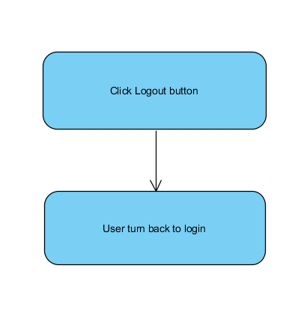

## Actor

-Administrator, Employee, Accountant

# Special Requirements

No Special Requirements

# Preconditions

No pre conditions

# Postconditions

Log in again

# Extension Point

Login again